Aequs EduTrack — Complete Platform Overview
Enterprise Educational CSR Management, Supply Chain Logistics & Outreach Platform

1. Executive Summary & Platform Mission
Aequs EduTrack is an integrated enterprise-grade educational CSR (Corporate Social Responsibility) and logistics management platform developed for the Aequs Foundation. Created to empower underprivileged students across government and partner schools in Karnataka (centered around the Belagavi industrial SEZ hub), EduTrack digitizes and unifies the entire educational assistance lifecycle.
The platform bridges institutional school administration, student academic performance, warehouse supply chain logistics, corporate industrial internships, and community volunteer recruitment into a single, cohesive, role-protected web portal.
Platform Name | Aequs EduTrack
Sponsor & Initiative | Aequs Foundation (Belagavi SEZ CSR Initiative)
System Architecture | Enterprise Django 6.1 MVT with Multi-Database Engine
Supported Databases | SQLite 3 (Local Dev), PostgreSQL (Cloud Production), Microsoft SQL Server (Enterprise On-Prem)
Security & Access | Role-Based Access Control (5 Custom Roles), Session Guards, Atomic Transactions
Operational Portals | Executive Dashboard, Schools, Students, Academics, Eligibility, Inventory, Internships, Volunteers, Reports
Quality & Verification | 78 Automated Test Cases (100% Passing in 5.6s), 0 Django System Check Warnings
Codebase Optimization | Purged 52 Legacy Backup Files (-29,811 Lines of Dead Code), Zero Dep Bloat

2. System Architecture & Technology Stack
EduTrack enforces a clean separation of concerns using Django's Model-View-Template pattern, zero-framework lightweight frontend rendering, and enterprise database flexibility:
Architectural Layer | Technology Stack | Implementation Role & Purpose
Backend MVC Core | Python 3.14, Django 6.1 | Core framework, ORM with atomic transactions, URL dispatcher, CSRF security
Frontend Presentation | Semantic HTML5, Vanilla CSS | Custom design system, CSS design tokens, responsive grid layouts, zero JS framework bloat
Design System | Aequs Royal Blue, Slate | Aequs branded royal blue (#1E3A8A / #2563EB) paired with modern shadcn card aesthetics
Vector Icons & Fonts | Lucide Icons, Segoe UI | Modern scalable SVG icon library delivered via CDN, crisp typography with locked compact scale
Multi-Database Tier | PostgreSQL, MSSQL, SQLite | Cloud production on PostgreSQL (Render), enterprise on-prem via ODBC (SQLEXPRESS), local SQLite
File & Asset Pipelines | Pillow, openpyxl, qrcode | Student photo uploads, automated Excel roster exports, live PNG QR generation with Reed-Solomon Level H
Production Deployment | Docker, Whitenoise, Gunicorn | Multi-stage container builds, compressed static streaming (Whitenoise 6.12), Gunicorn WSGI workers

3. Role-Based Access Control (RBAC)
The platform protects sensitive student data and operations across 5 distinct user roles:
User Role | Accessible Portals | Operational Permissions & Duties
Super Admin | Global Platform Access | Full administrative control, user provisioning, role assignments, system-wide compliance and audit logging.
School Admin | Schools, Students, Academics, Inventory | Student admissions, bulk CSV uploads, grade recording, academic promotion, and classroom allocations.
Accountant | Distributions, Inventory, Reports, Exports | Approves material disbursements, tracks laptop asset serials, runs financial audits, and exports Excel reports.
Event Coordinator | Events Portal, Resource Requests, Internships | Organizes community workshops and distribution drives, requisitions warehouse equipment, manages intern cohorts.
Volunteer | Volunteer Portal, Event Participation | Views assigned school visits and distribution events, logs service hours, and tracks personal contribution history.

4. Core Functional Modules Deep-Dive

4.1. Partner School Administration (schools)
- Comprehensive directory storing school name, government UDISE code, geographical taluk/village, and headmaster contact details.
- Grade-Level Strength Matrix: Live tracking of student headcount breakdowns across Classes 1 through 10.
- Infrastructure & Asset Registry: Logs educational equipment installed at partner schools, including computer labs, smart TVs, and libraries.
- Institutional Milestone Timeline: Records grants, infrastructure inaugurations, and foundation achievements.

4.2. Student Identity & Roster Management (students)
- Central identity management with admission numbers, gender, date of birth, category, contact info, and assigned partner school.
- High-Speed CSV Bulk Ingestion: Batch import pipeline with strict validation, duplicate detection, and atomic rollback on errors.
- Multi-Attribute Filter Bar: Real-time filtering by search query, school, class equivalent, gender, and active enrollment status.

4.3. Academics & CourseMaster Engine (academics)
- Academic Performance Records: Tracks subject marks, total scores, automatic percentage calculation, and class standings.
- Automated Promotion Pipeline: Evaluates student performance into Promoted, Conditional, or Non-Promoted standing.
- Dynamic CourseMaster: Extensible catalog clearly distinguishing primary/secondary school classes from collegiate degree courses (PUC, ITI, Diploma, BE).

4.4. Student Benefit Eligibility Matrix (eligibility)
- Rule Engine: Evaluates student qualifications across 5 core CSR benefit categories (Textbooks, Workbooks, Study Kits, Laptops, Internships).
- Smart Educational Resolver: Seamlessly maps equivalent academic terms ('10th' <-> 'Class 10', 'PUC' <-> '12th') to eliminate classification bugs.
- Dynamic Benefit Filtering: Allows foundation administrators to immediately filter candidate pools meeting exact merit criteria.

4.5. Warehouse Supply Chain & Laptop Assets (inventory)
- Stock Transaction Ledger: Real-time logging of stock-in (donor/vendor receipts) and stock-out (distributions) for school kits.
- Low-Stock Visual Indicators: Automated badges (In Stock, Low Stock, Depleted) warning logistics staff when stock falls below safety thresholds.
- Laptop Asset Lifecycle: Tracks serial numbers, processor specifications, student assignment records, and hardware return processing.

4.6. Benefit Distributions Logistics (distributions)
- Logistics Ledger: Verifies student qualification prior to material issuance, preventing duplicate or unauthorized distributions.
- Study Kit Assembly: Bundling logic combining school bags, geometry sets, stationery, and notebooks into standardized kits.
- Handover Receipts: Digital distribution records logging issuer, recipient signature/acknowledgement, and distribution date.

4.7. Corporate Industrial Internships (internships)
- Manufacturing Training Tracks: Program administration at Aequs SEZ manufacturing units (CNC machining, aerospace tooling, QA, assembly).
- Candidate Pool & Placement: Matches qualified vocational and diploma candidates to corporate engineering mentors.
- Milestone & Stipend Ledger: Tracks monthly intern attendance, stipend disbursements, performance evaluations, and completion certificates.

4.8. Community Events & Resource Requisition (events)
- Event Planning Workflow: Manages educational workshops, distribution ceremonies, health checkup camps, and school visits.
- Cross-Module Resource Requests: Directly links events to warehouse inventory, allowing coordinators to reserve study kits in advance.
- Volunteer Deployment: Assigns registered community volunteers to specific event roles and track attendance.

4.9. Volunteer Portal & Live QR Registration (volunteers)
- Volunteer Directory: Profiles tracking volunteer skills, occupation, qualification, and cumulative service hours contributed.
- Tokenized Link Generator: Generates unique, secure sharing links (VolunteerFormLink) for community recruitment campaigns.
- Live Dynamic PNG QR Code: Embedded generator outputting scannable high-density QR codes (Reed-Solomon Level H) downloadable for print and web.
- Public Self-Registration: Standalone, mobile-responsive registration portal allowing prospective volunteers to register directly online.

4.10. Executive Reporting & Compliance Audit (reports)
- Executive KPI Dashboard: Instant consolidated metrics across partner schools, student headcount, laptops distributed, and active volunteers.
- Real-time JSON Logs API: Asynchronous endpoint (/reports/api/logs/) supporting live audit log streaming without full page reloads.
- AuditLogMiddleware: Automatic request-level logging capturing user logins, CRUD modifications, object IDs, and IP addresses.
- One-Click Data Exports: Dedicated export handlers producing formatted CSV and Excel (.xlsx) reports for government compliance.

5. Engineering Roadmap & Visual Timeline
Visual Gantt chart and module release evolution tracing the platform's development lifecycle:
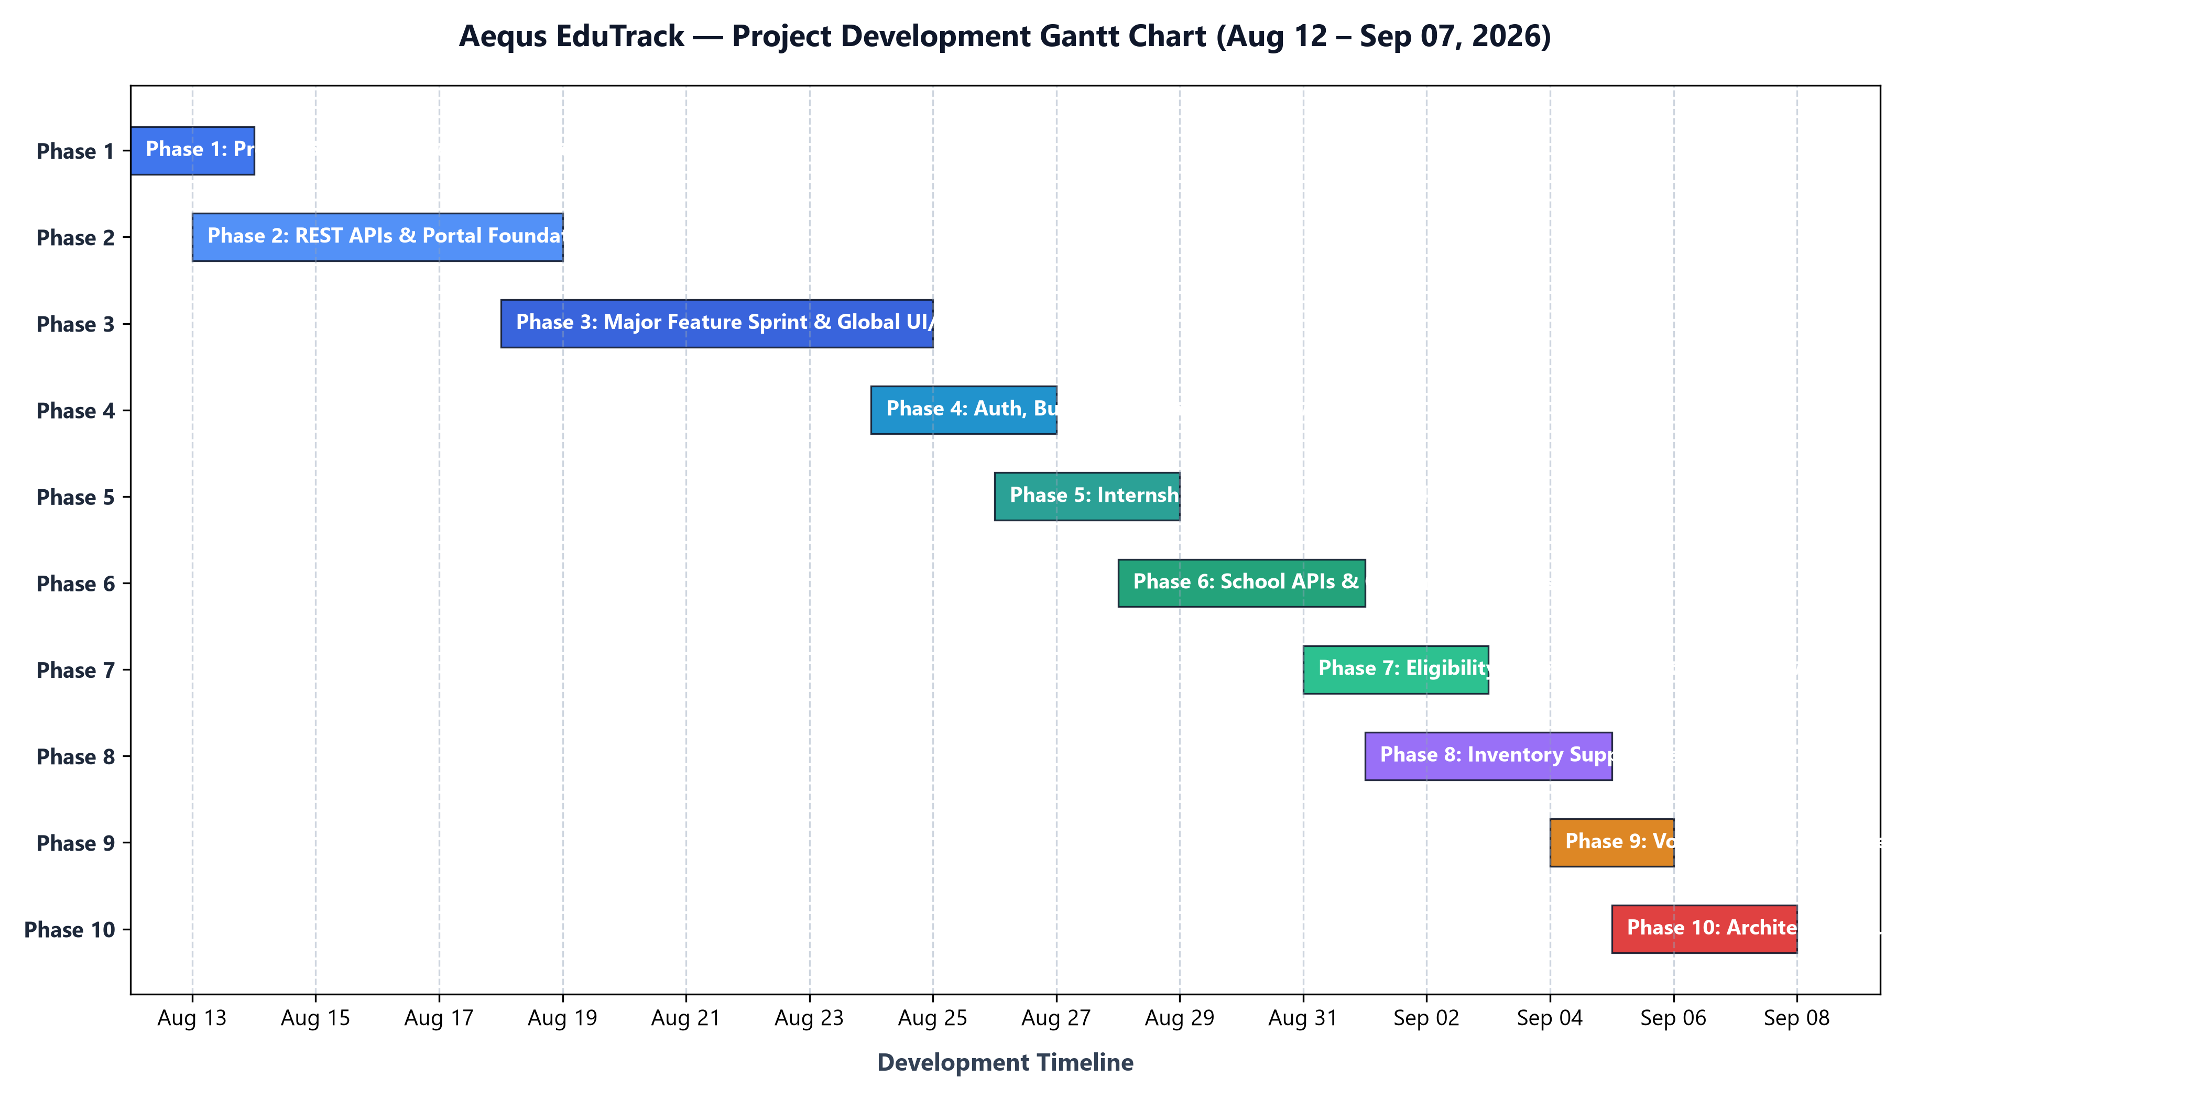
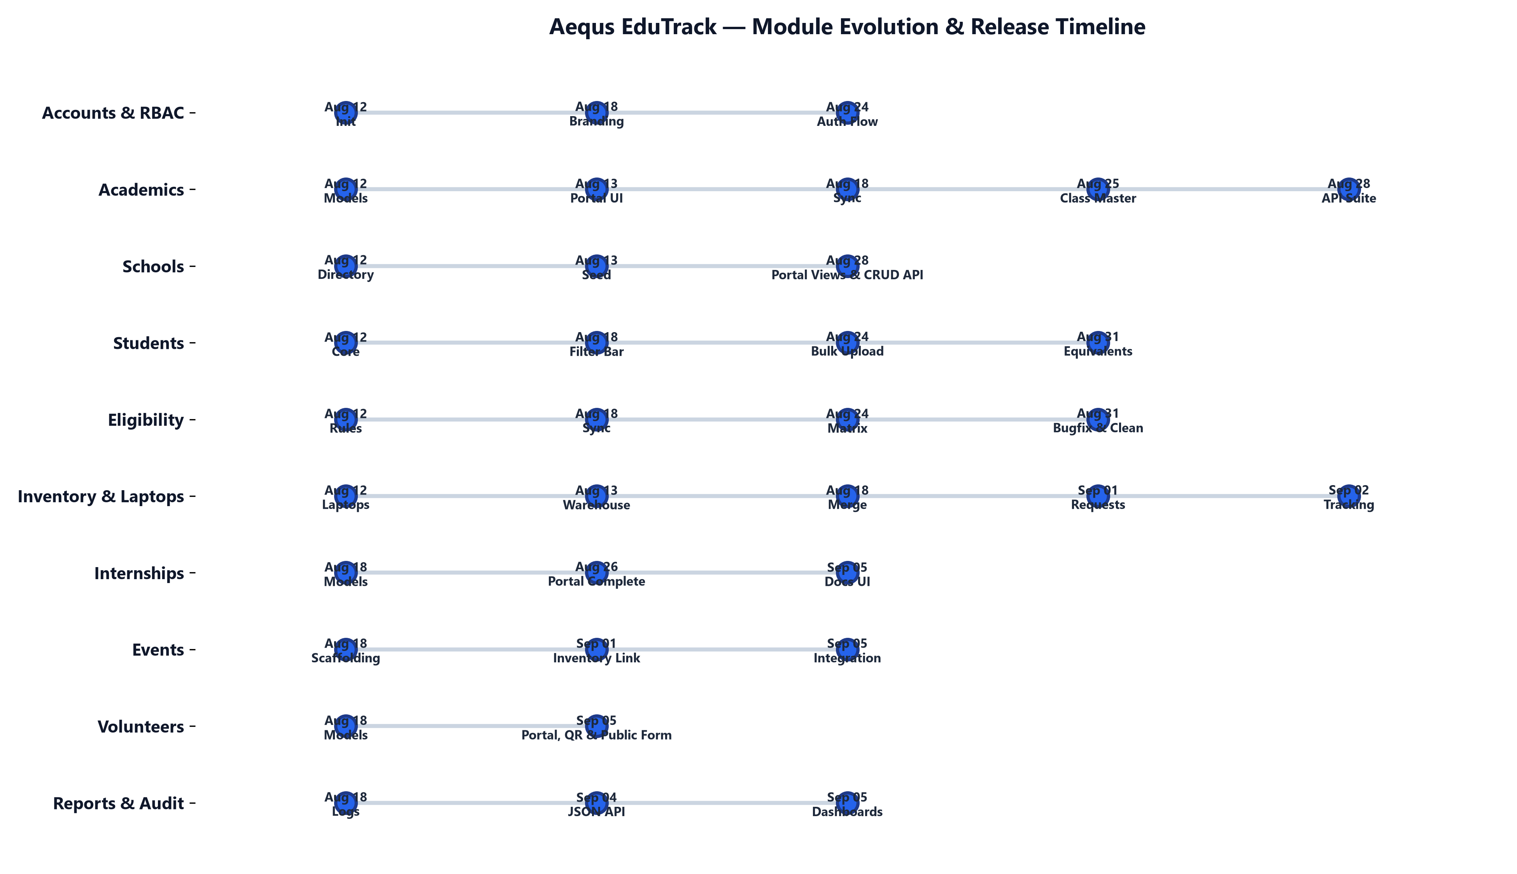

6. Quality Verification & Codebase Optimization
Aequs EduTrack adheres to rigorous enterprise quality standards, zero-bloat architecture, and complete test verification:
• Automated Test Suite: 78 unit and integration test cases covering school management APIs, student model constraints, and inventory movements. Result: 78/78 tests passed in 5.62s with zero failures.
• Django System Check: python manage.py check reports: System check identified no issues (0 silenced). Zero misconfigurations or routing warnings.
• Architectural Audit: Eliminated 52 legacy backup and text dump files (-29,811 lines of dead code), purged 5 empty skeleton apps, and unified QR generator views into a single high-performance handler.
• Data Safety Guarantees: Atomic transactions (@transaction.atomic) wrap all batch CSV uploads and student distribution workflows, guaranteeing clean rollbacks if unexpected errors occur.

7. Engineering Team Share (61 Total Commits)
The platform was engineered over 27 calendar days (August 12 – September 07, 2026) across 14 active development days by two primary software engineers:
Contributor | Commits | Share | Core Engineering Responsibilities
Rishab / Code-Cool-2006 | 42 commits | 69% | Lead Architect, UI/UX & Systems Engineer  Modular REST APIs, UI/UX Design System, School Portal, Automated Test Suite (78 tests), Volunteer Management System, Live QR Generation, Production DevOps (Docker, Render, Whitenoise), Codebase Optimization (-29,811 lines).
Saloni Dalvi / salonidalvi-008 | 19 commits | 31% | Core Services & Logistics Engineer  Initial project foundation and core schema scaffolding (13 apps), Benefit distribution services, CourseMaster dynamic streams, Enterprise Microsoft SQL Server integration, Internship Portal, Eligibility bugfixes, Bulk CSV pipelines.

Aequs EduTrack Complete Platform Overview • September 07, 2026
© 2026 Aequs Foundation. All rights reserved.

